Financial document (must be completed by the candidate)

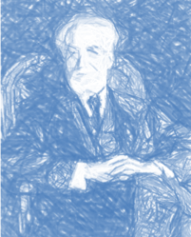

TITLE OF CHAIR PROJECT:

Budget for PROJECT | …… € HT |  | € TTC
Family name, first name of the candidate:

Name of head of host laboratory:

Title of host laboratory:

Evaluation of expenses :
Différents postes |  | € HT |  | € TTC
- Recurrent costs:

  - Purchase of small materials
  - Other consumables
  - Charges for services

- Expenses related to stay

  - Travel expenses
  - Accomodation:

- Other:

TOTAL

